16/2/2021

Problem-1)

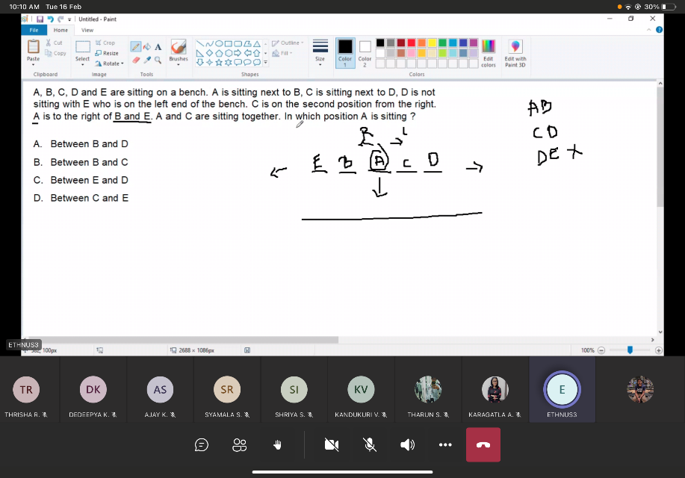

Problem-2)

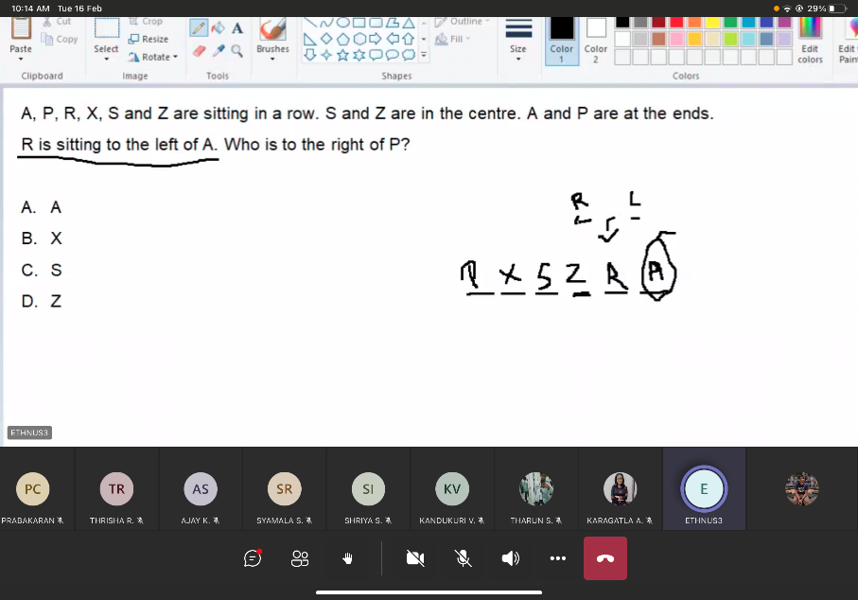

Problem-3)

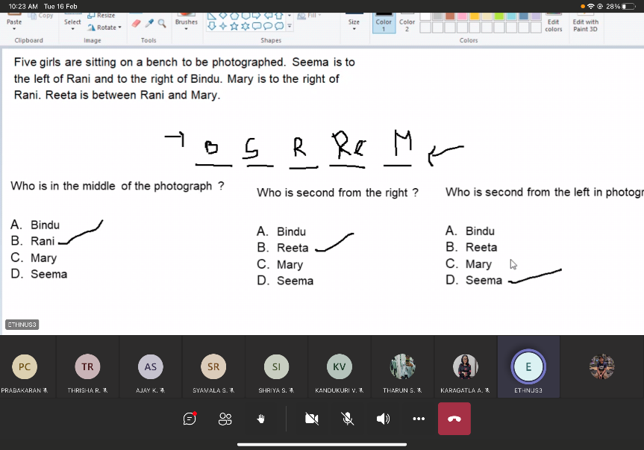

Problem-4)  
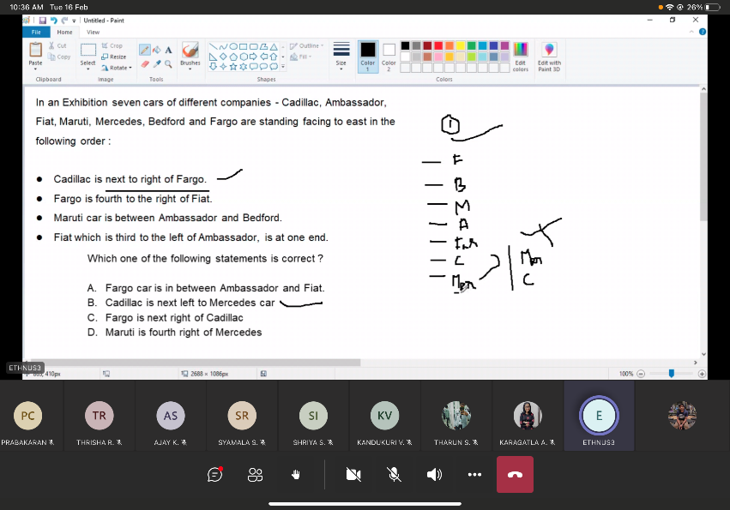

Fiat, Bedford, Maruti, Ambassador ,Fargo, Cadillac, Mercedes  
 3 2 1 (fiat which is third to the left of ambassador)  
 1 2 3 4 (Fargo is fourth to the right of fiat)

18-02-2021

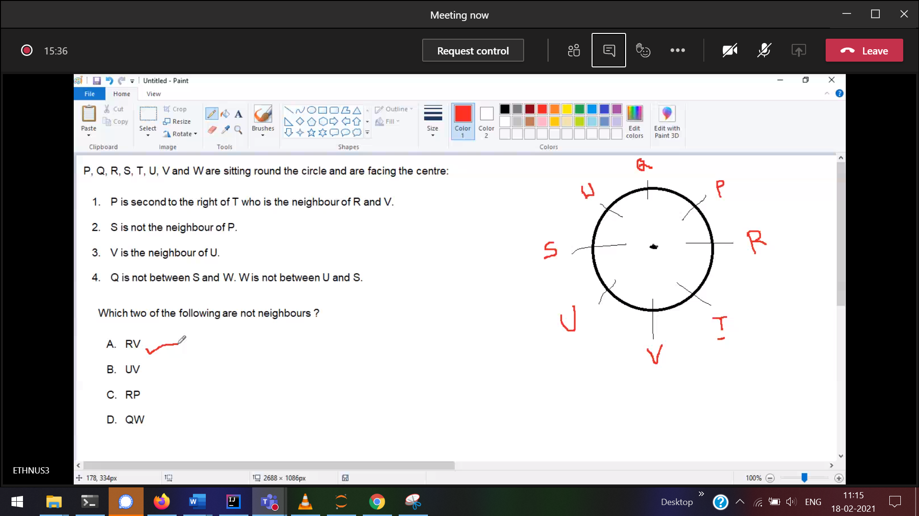  
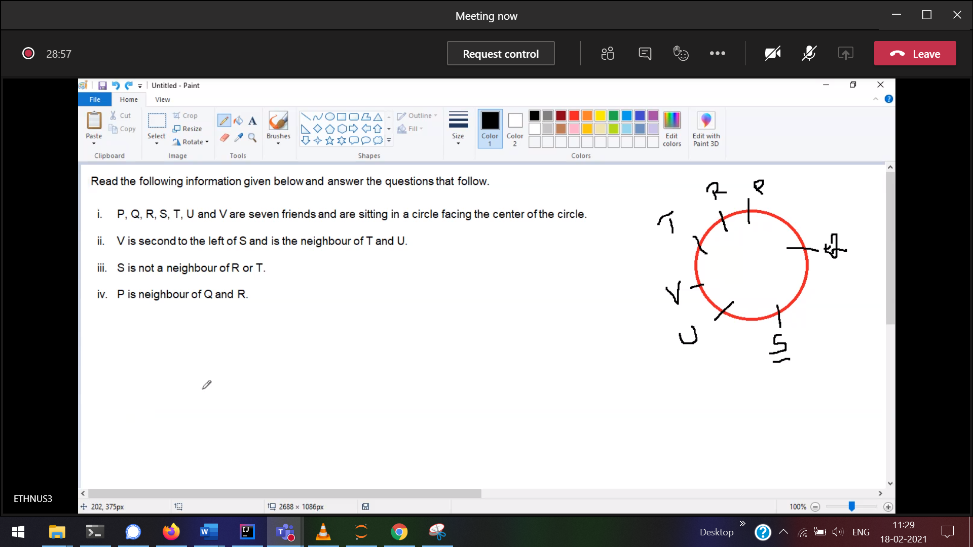  
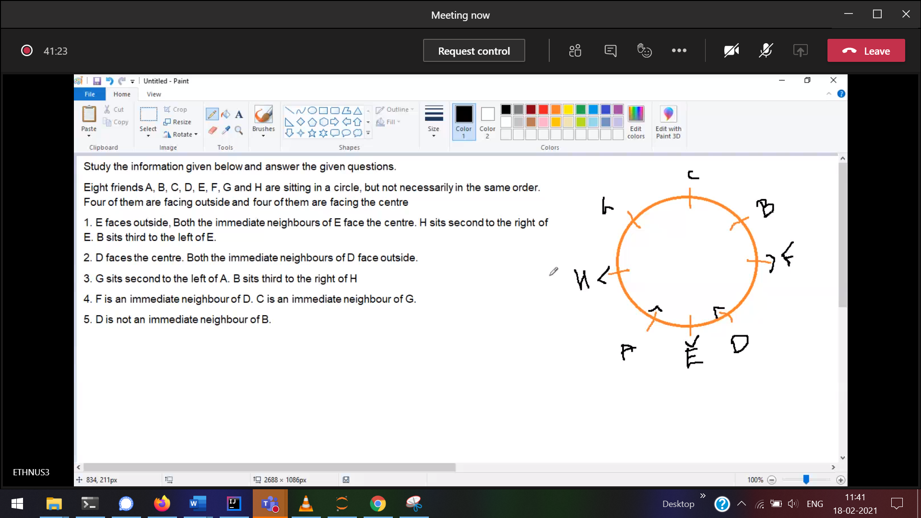

19/2/2021

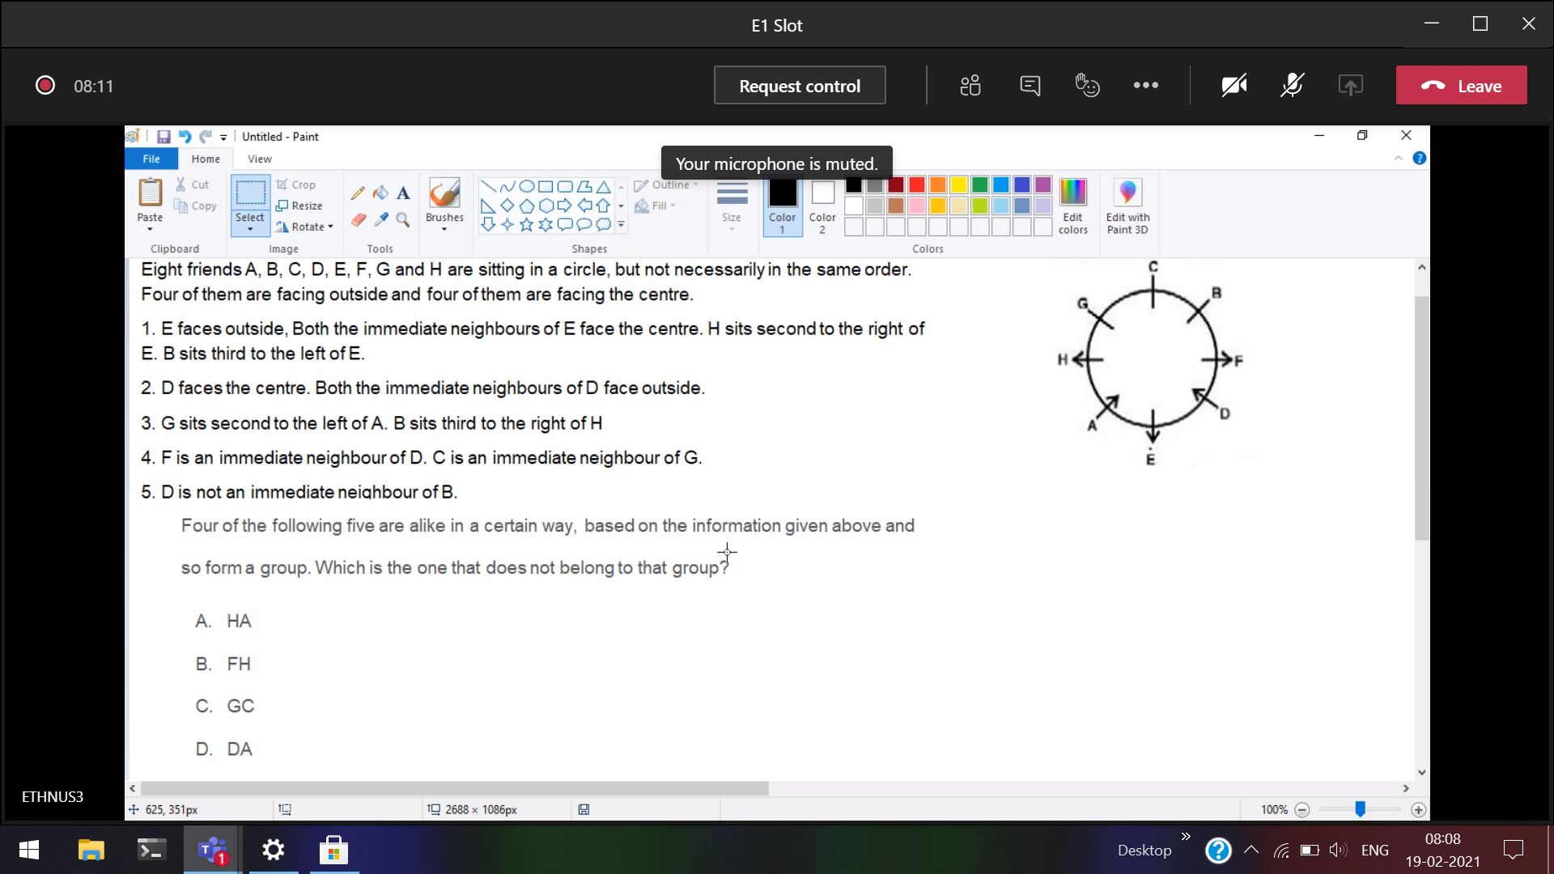

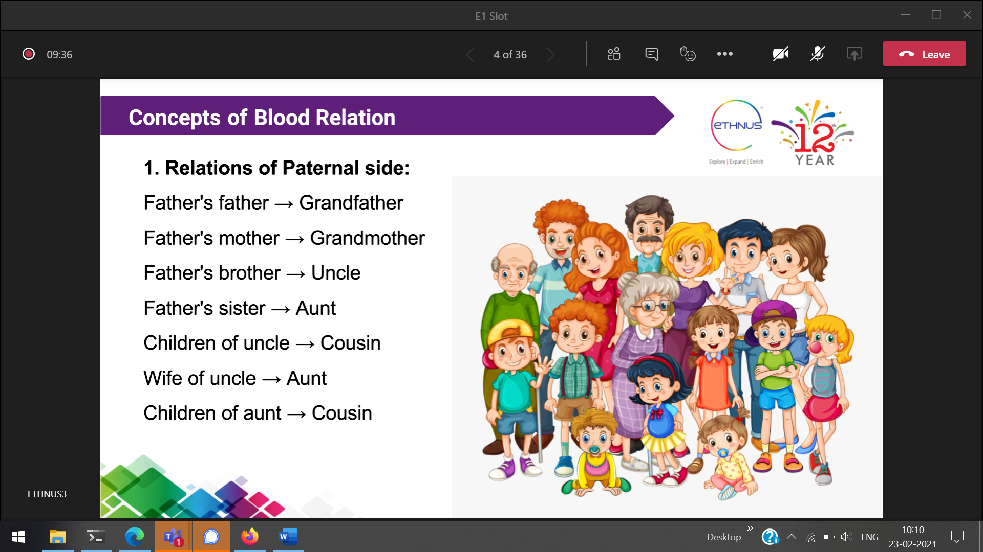  
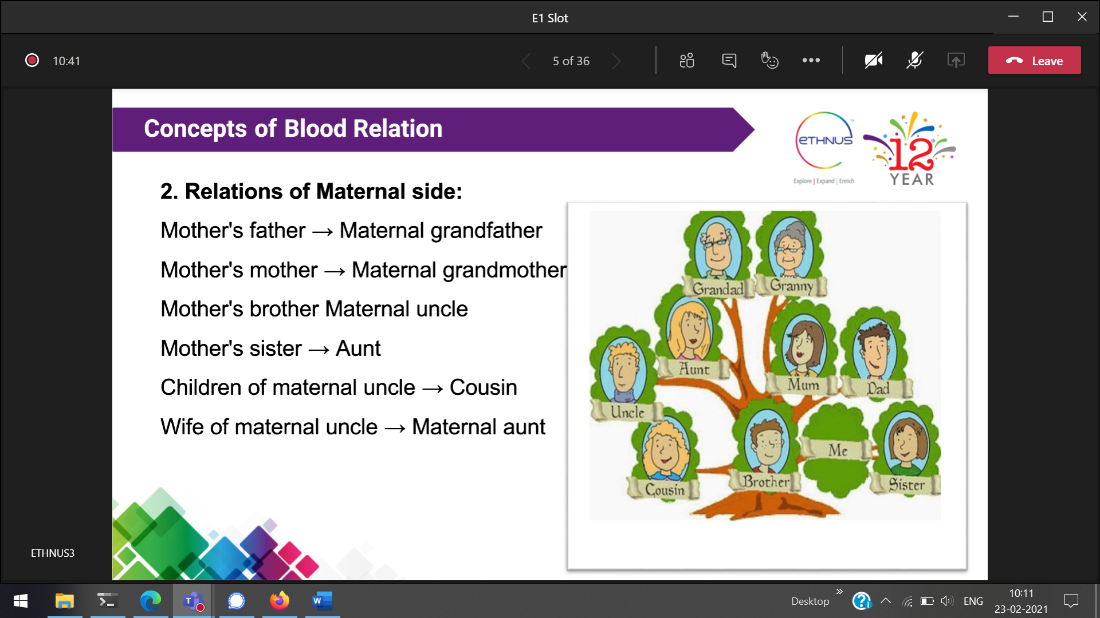

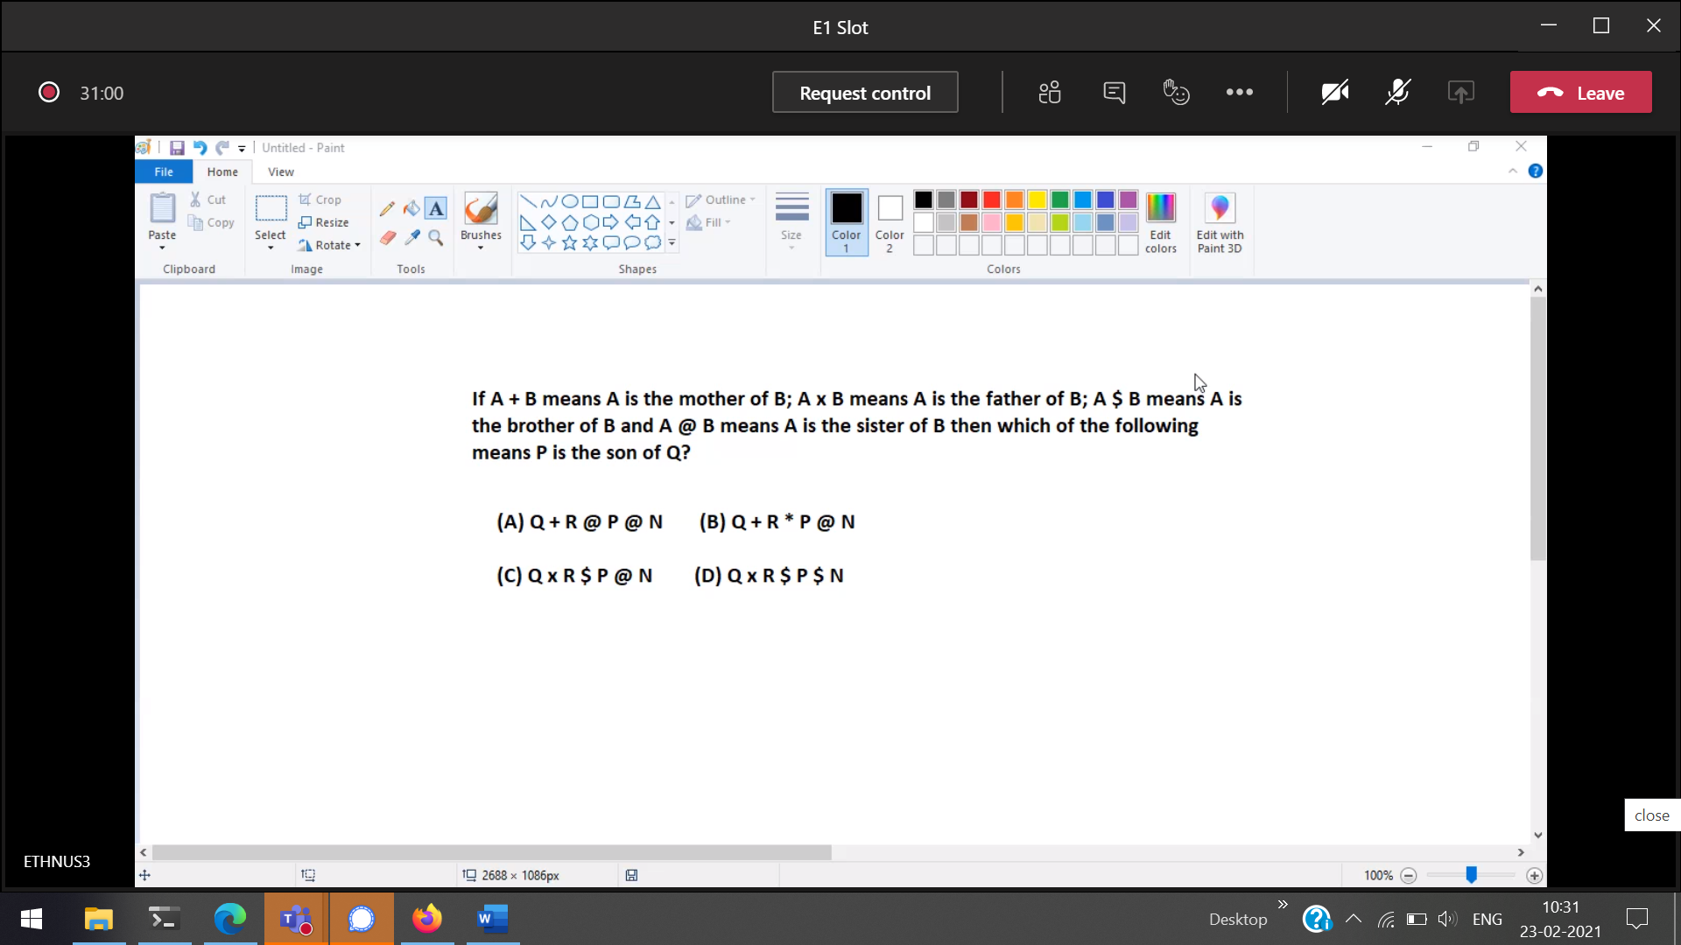



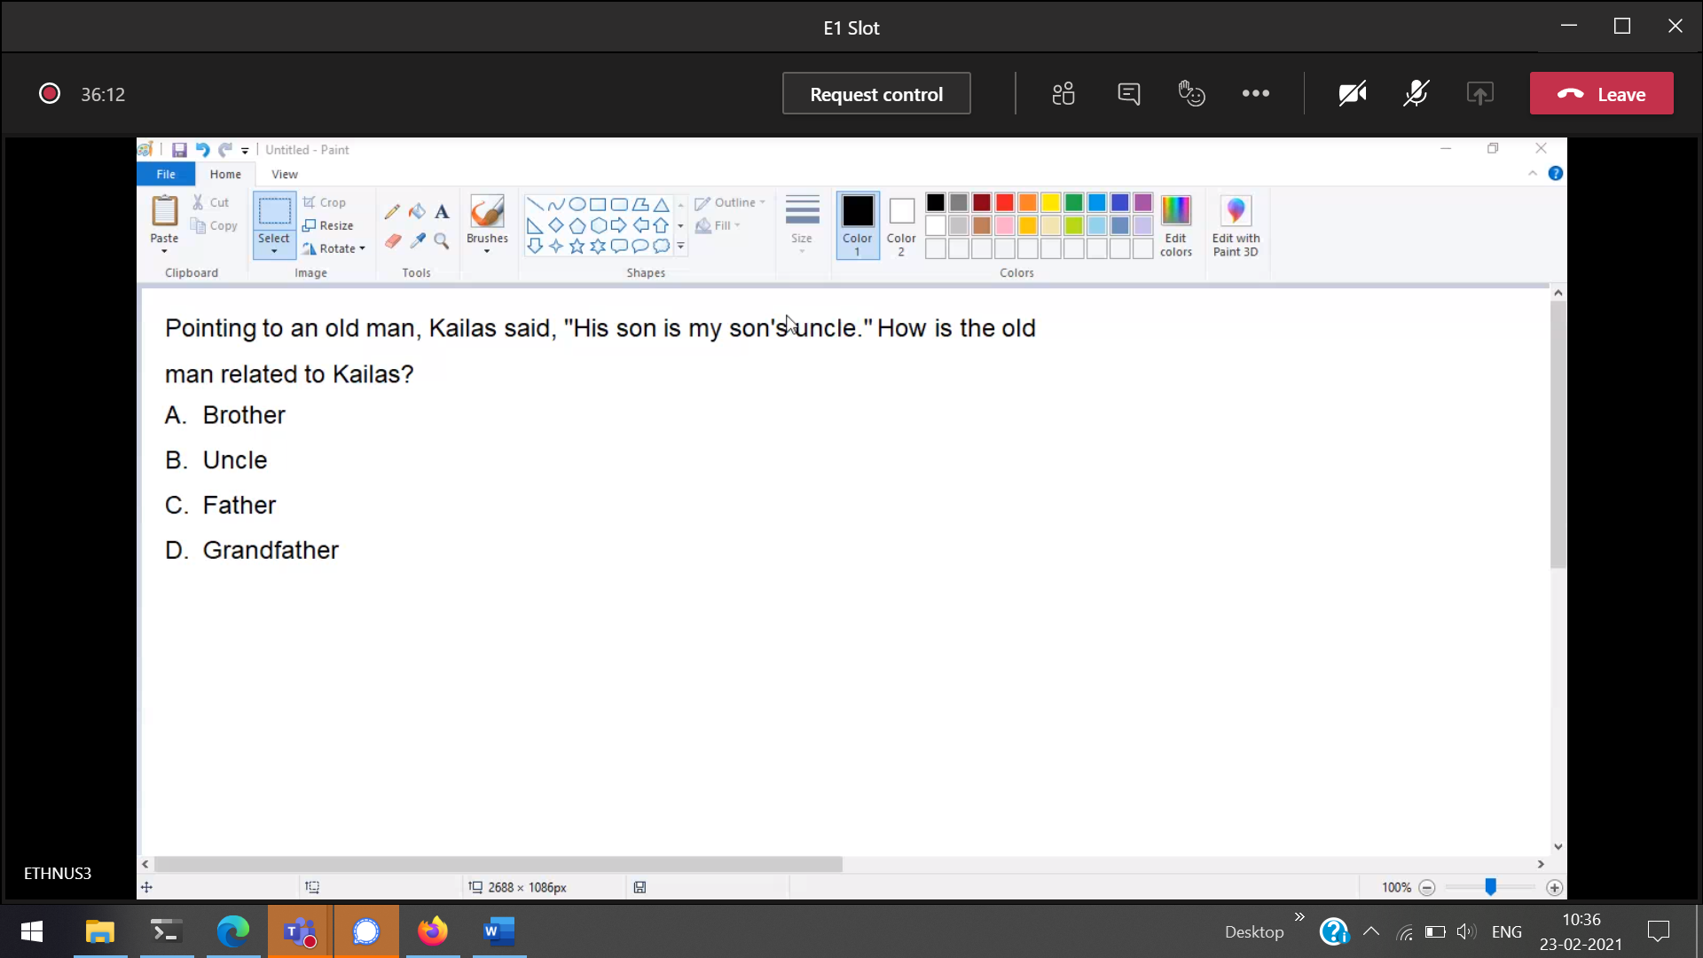



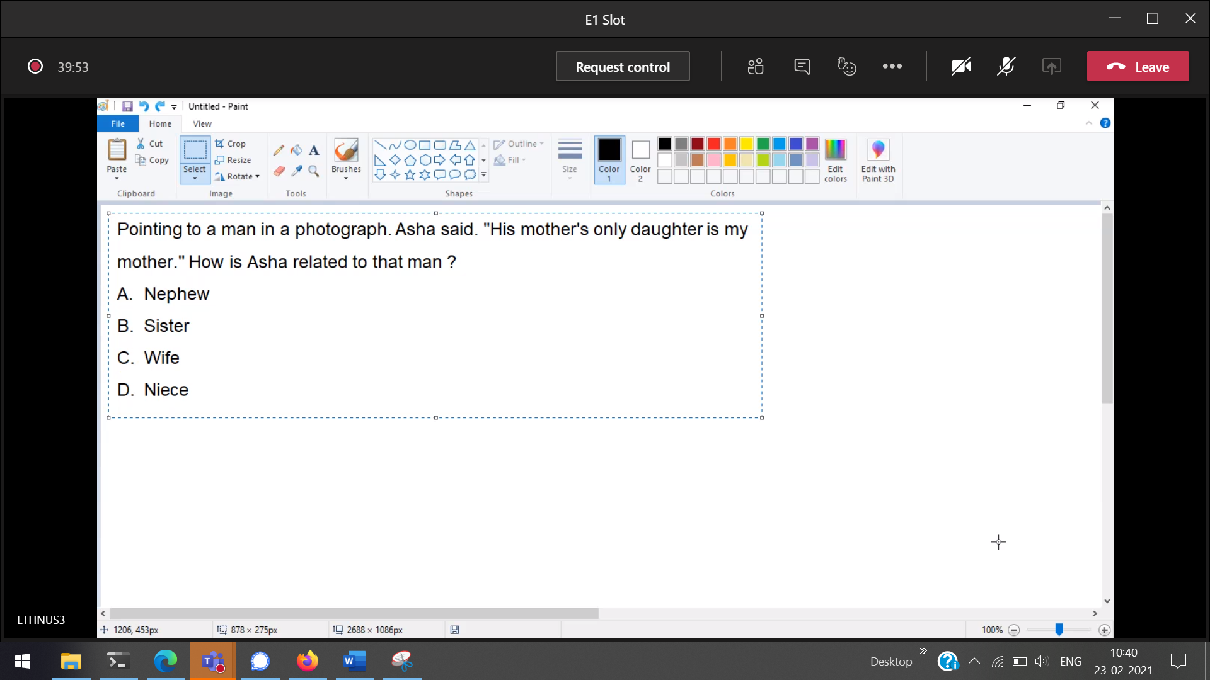



Pointing to a girl in the photograph, Amar said, "Her mother's brother is the only

son of my mother's father." How is the girl's mother related to Amar ?

Ans 🡪 aunt

Muthu said, “This girl is the wife of the grandson of my mother who has only one

son.” Who is Muthu to the girl?

muthu : father in law to that girl

Pointing to a photograph, Vipul said, "She is the daughter of my grandfather’s

only son". How is Vipul related to the girl in the photograph?

Vipul:brother

If  (A) P + Q means P is the brother of Q ;  
    (B) P x Q means P is the father of Q ;  
    (C) P - Q means P is the sister of Q ;

which of the following represents S is the niece of T ?

A.T x M + S – K

B.K - S x M + T

C.T + M x S – K

D.T x S + M – K

Ans 🡪 c

Size of two things  
Ratio 🡪 a : b  
Proportion 🡪 a : b : : c : d

**Properties of proportion**

1. Addendo – If a : b = c : d, then a + c : b + d  
   Subtrahendo – If a : b = c : d, then a – c : b – d  
   Dividendo – If a : b = c : d, then a – b : b = c – d : d  
   Componendo – If a : b = c : d, then a + b : b = c+d : d  
   Alternendo – If a : b = c : d, then a : c = b : d  
   Invertendo – If a : b = c : d, then b : a = d : c

if u/v = x/y, then uy = vx  
If u/v = x/y, then u/x = v/y  
If u/v = x/y, then v/u = y/x  
If u/v = x/y, then (u+v)/v = (x+y)/y  
If u/v = x/y, then (u-v)/v = (x-y)/y  
componendo - Dividendo Rule 🡪 if u/v = x/y, then (u+v)/ (u-v) = (x+y)/(x-y)   
Important

a : b : : c : d 🡪 a,d are extreme terms and b,c are mean terms

In a : b = c : d, b and c are called

In ratio a : b, the first term a is called 🡪 antecedent   
In ratio a : b, the second term b 🡪 consequent

A statement which is expressed as an equivalence of two ratios is known as (Ans🡪proportions)

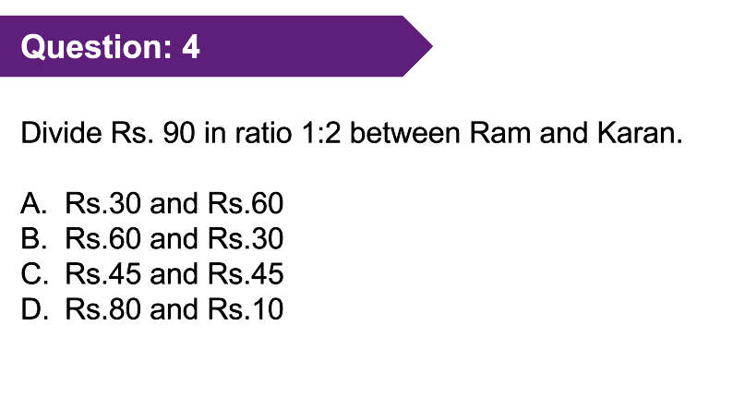

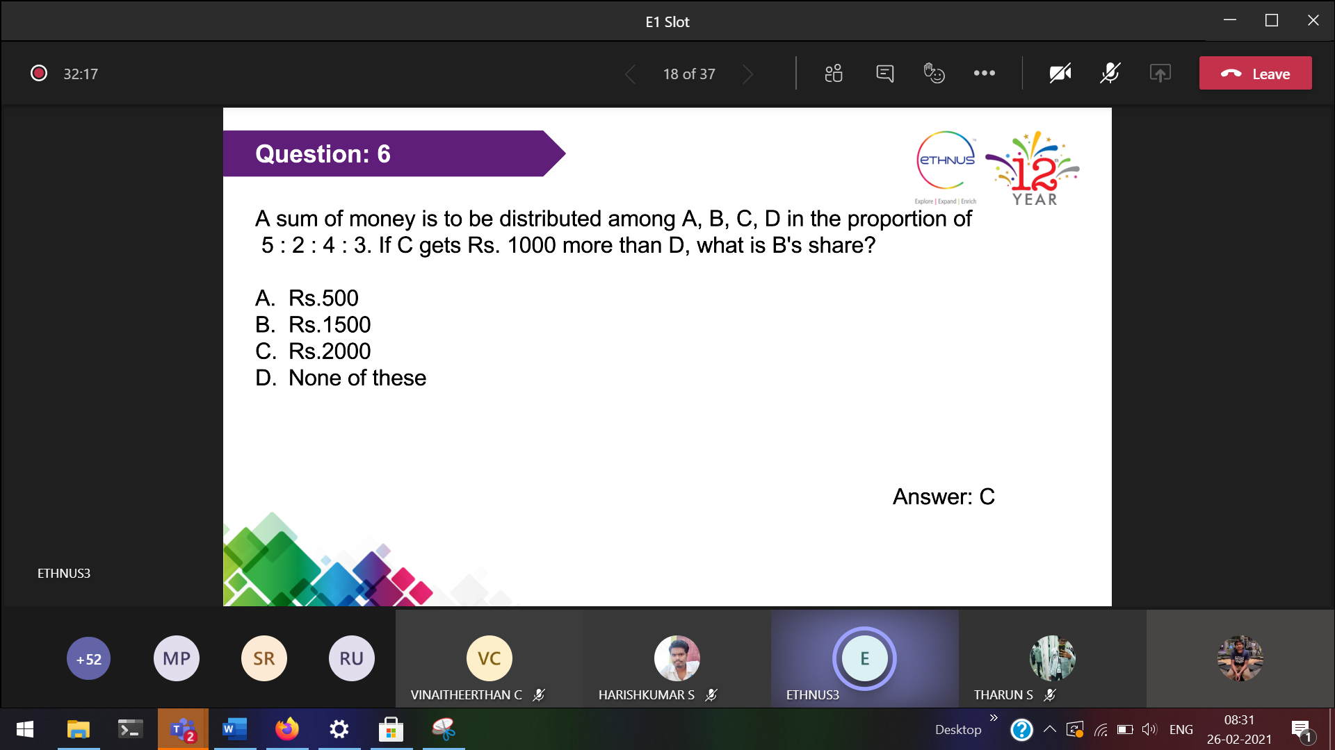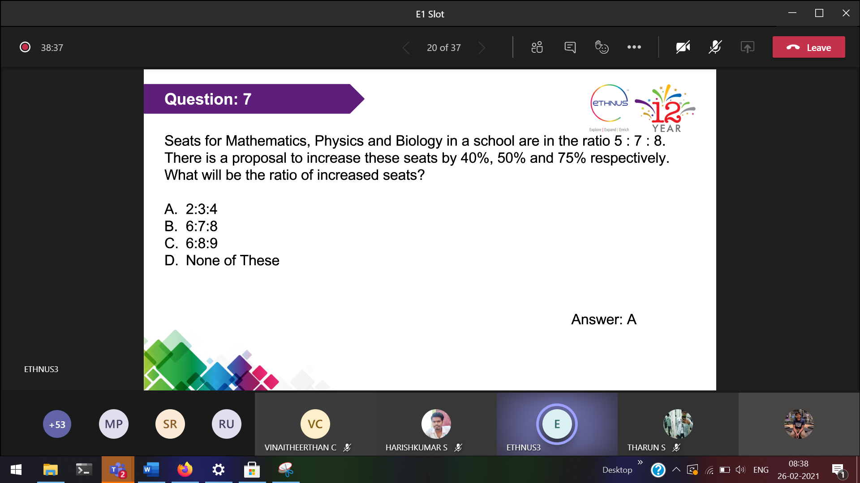  
(140/100 x 5x),(150/100 x 7x),(175/100 x 8x)  
7x 21x/2 and 14x  
14x 21x 28x

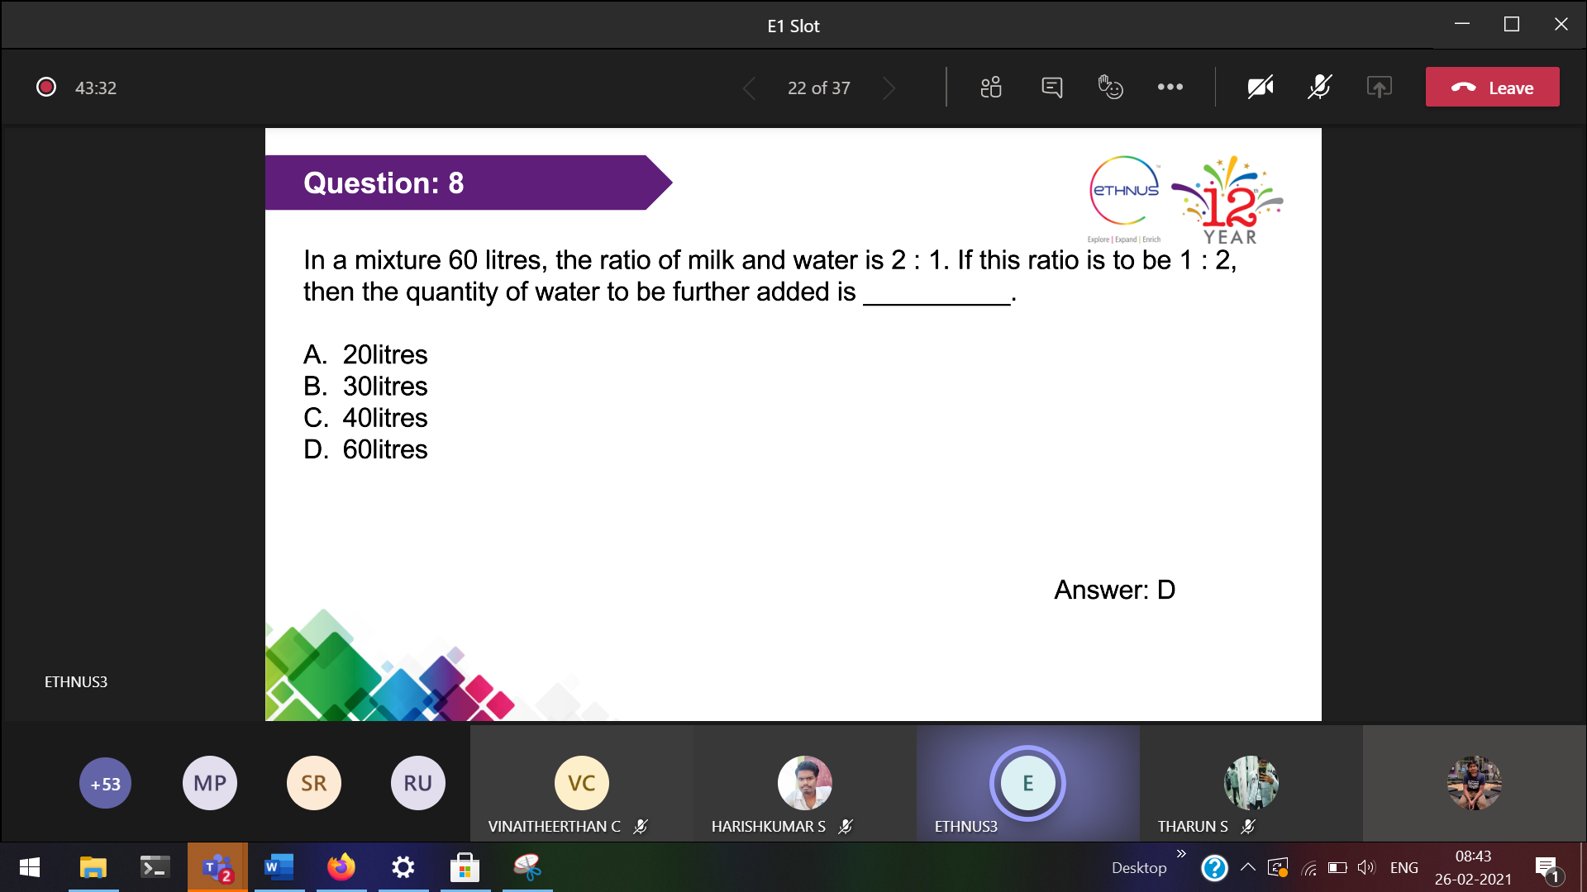

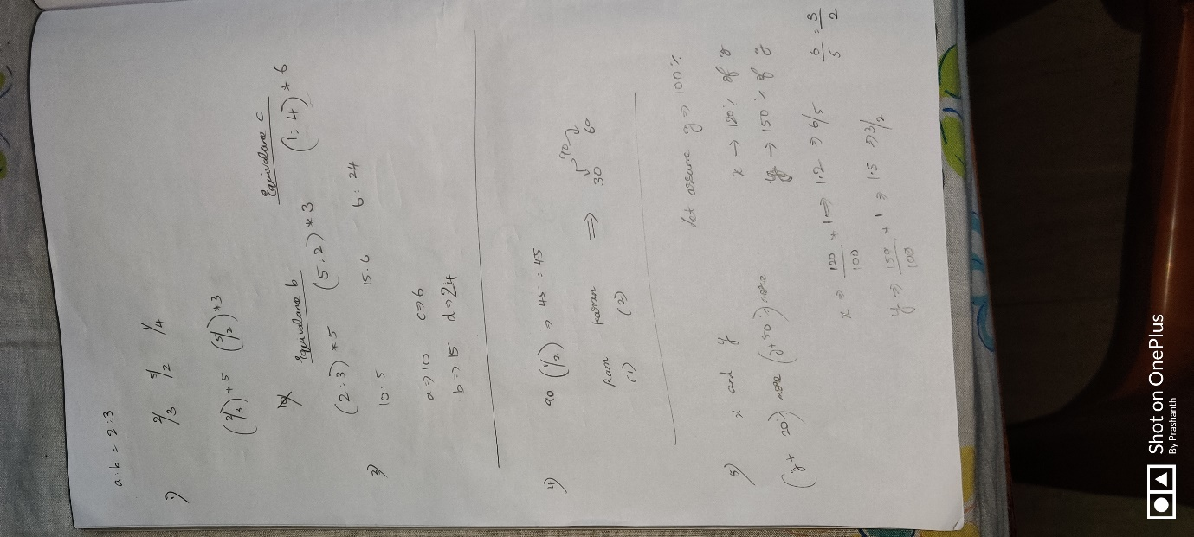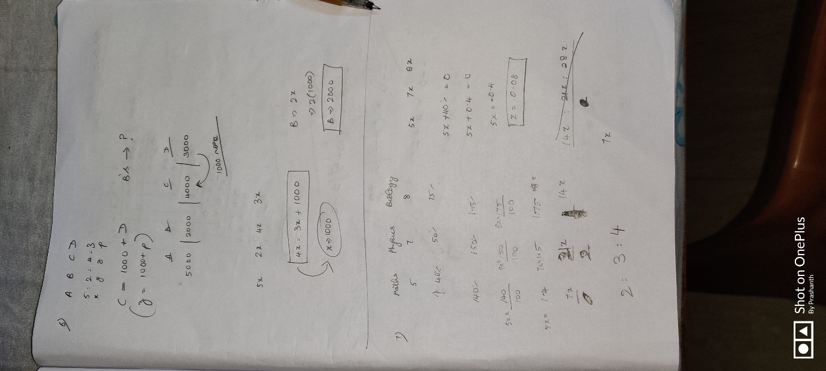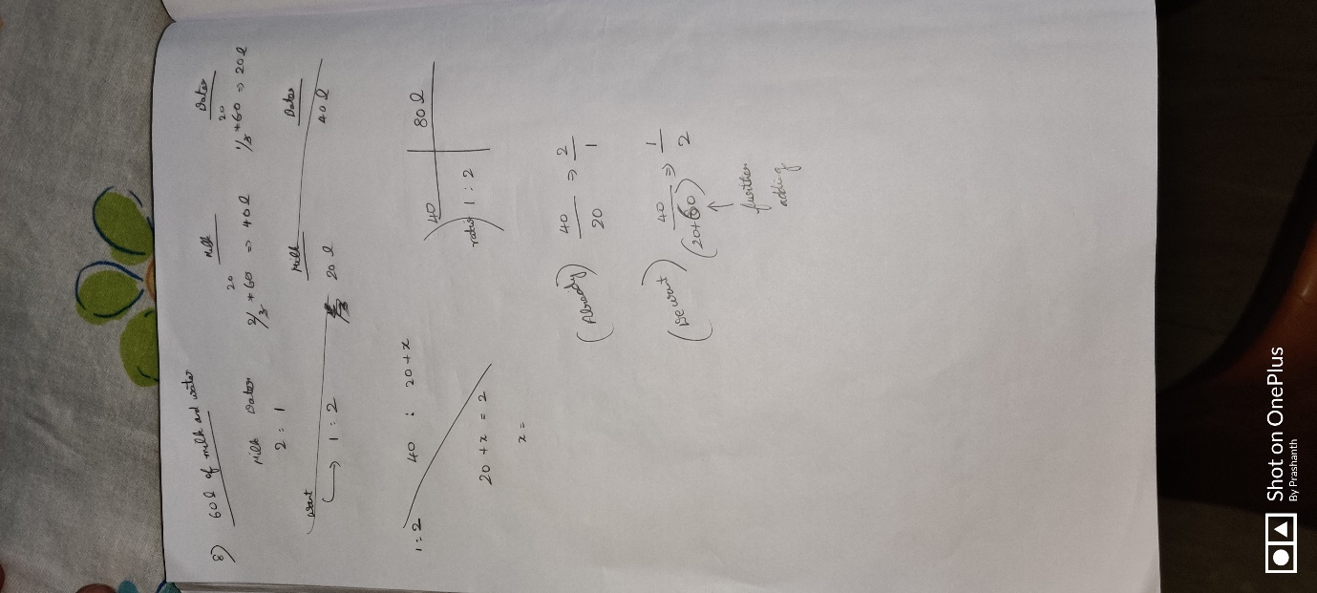

2/3/2021

Variation deals with how one quantity changes with respect to one or more other quantities.  
A combination of direct and inverse variations of one or more than one variables is known as Ans 🡪 Join variation

The quantity of wooden box made is directly proportional to the number of wooden blocks. The number of wooden blocks needed for 30 boxes is 120. How much wooden blocks are needed for a box? Ans🡪 120/30 🡪 4

**9 pipes are required to fill a tank in 4 hours. How long will it take if 12 pipes of the same type are used? Ans 🡪 5.33 hrs**

**If 24 workers can build a house in 40 days, how many workers will be required to build the same house in 20 days? Ans 🡪 48**

**There are 100 students in a hostel. Food provision for them is for 20 days. After 8 days 20 new students entered into the hostel. How long will this provision last now?  
Ans 🡪 (10 + 8) 🡪 18days**

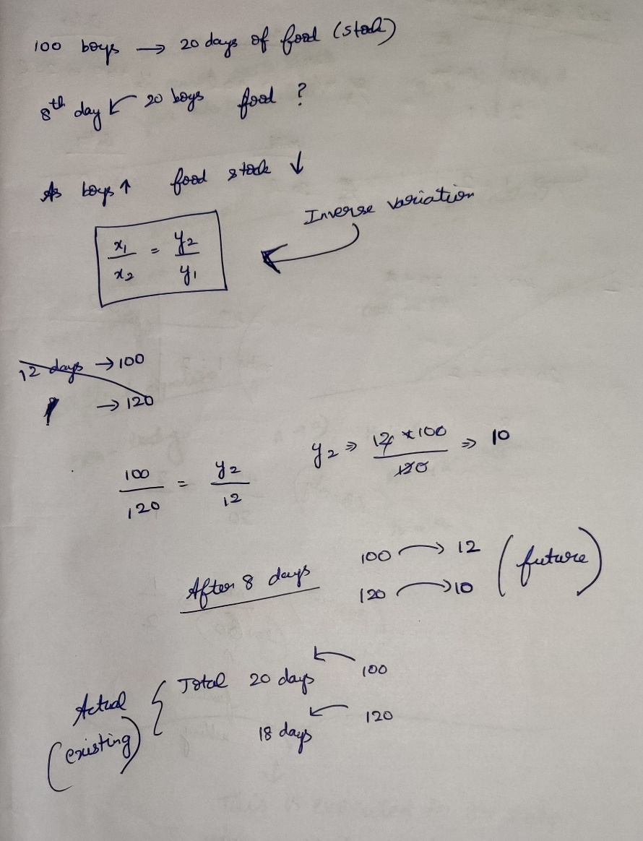

If two quantities are related in such a way that increase in 1 quantity causes increase in other quantity, then this variation is said to be Ans🡪direct variation

Direct variation 🡪 (x1/x2) = (y1/y2)  
Indirect variation 🡪 (x1/x2) = (y2/y1)

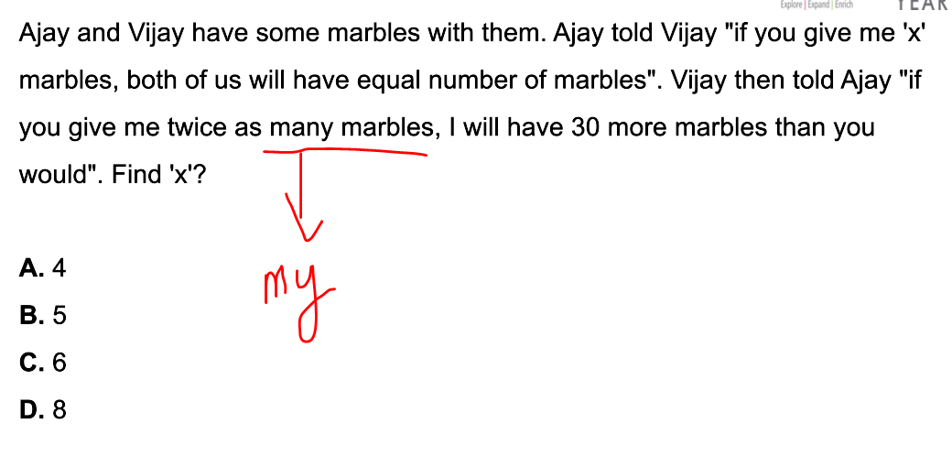



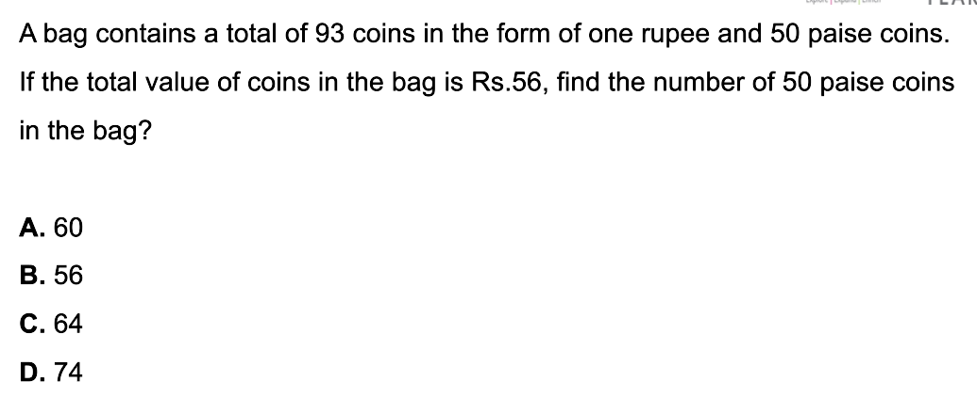  
[100x + 50(93 - x)]paise = 5600 paise